UMGC CMSC 495

WEEKLY Project Status Report

|  |
| --- |
| Project Name: Team 3 USACE Work Request Application |
| Date: 20211123 (Week 5) |
| Project Manager: Dave Leake |

# 1.0 Milestones and Schedule Dates

|  |  |  |
| --- | --- | --- |
| **Milestones** | **Estimated Completion Date** | **Percent**  **Complete** |
| User Guide | 20211106 | 100 |
| Test Plan | 20211108 | 100 |
| User Experience | 20211109 | 100 |
| Design | 20211116 | 100 |
| Source drop 1 Hello World | 20211123 | 100 |

# 2.0 Accomplishments This Period

## 2.1 Activities

Project Management Burndown

Demoed the IDE and project submission process

## 2.2 Activities Planned But Not Achieved

Hello world: Submit WorkRequest User Table Read stored proc

## 2.3 Deliverables Completed

DB Sync and project sync methodology

Azure Proof of concept to support final project db placement

## 2.4 Deliverables Planned But Not Completed

N/A

# 3.0 Accomplishments Planned for Next Period

## 3.1 Activities

Design a user interface

Refine Table structure to project scope

## 3.2 Deliverables

Earned Value Analysis

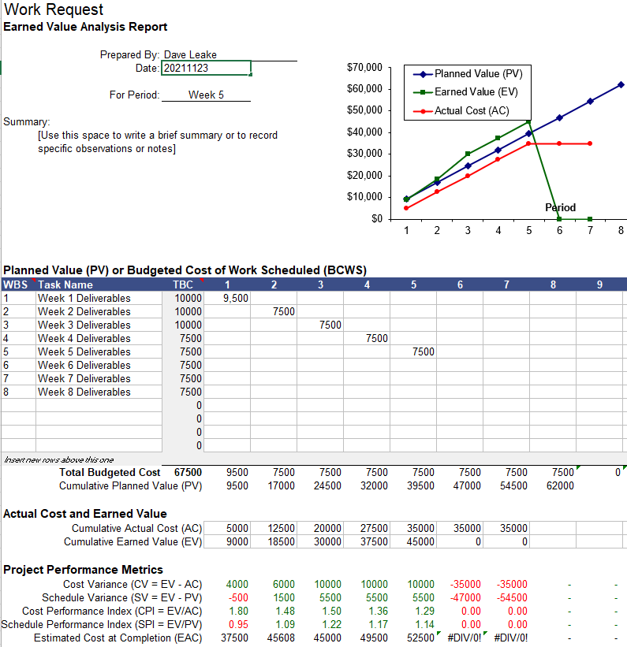

# 4.0 To Date Earned Values

|  |  |  |  |  |  |  |  |  |
| --- | --- | --- | --- | --- | --- | --- | --- | --- |
|  | PV | AC | EV | CV | SV | CPI | SPI | EAC |
| Current | 39500 | 3500 | 45000 | 10000 | 5500 | 1.29 | 1.14 | 52500 |

|  |  |  |
| --- | --- | --- |
| * Earned Value Indicators: | | |
| * PV = Planned Value or Budgeted Cost of Work Scheduled * AC = Actual Cost of Work Performed * EV = Earned Value or Budgeted Cost of Work Performed, | * CV = Cost Variance * SV = Schedule Variance * CPI = Cost Performance Index | * SPI = Schedule Performance Index * EAC = Estimate at Completion |

20211123DL: Project is on s

UMGC CMSC 495

# 5.0 Risks and Issues Summary

## 5.1 New

[List the new major risks or issues that will be addressed in the next period.]

|  |  |  |  |
| --- | --- | --- | --- |
| Risk/Issue # | Description | Action | Owner |
| Changes to IDE | Chosen products licensing may impede this project and force another route | Research new terms. Provide COAs. | IAN |
|  |  |  |  |
|  |  |  |  |

## 5.2 History

[List the previous major risks and issues for the project. The Project Risk Log, AMC-PMO-307, and the Project Issue Log, AMC-PMO-310, may be attached for further support.]

|  |  |  |  |
| --- | --- | --- | --- |
| Risk/Issue # | Description | Status  (Open/Closed) | Owner |
| Employee Skills | Need to gauge current team member skill sets, leverage where appropriate | Work with Team members to gauge | Dave |
|  |  |  |  |
|  |  |  |  |

# Change Request Summary

[List the changes requested that might impact scope, schedule, and cost.]

|  |  |  |  |
| --- | --- | --- | --- |
| Change ID # | Description | Change Request Type  (Defect Repair, Enhancement, Addition, etc.) | Status |
| OverTime Request | Need to approve overtime to participating team members to keep project on schedule | Personnel Shortage | Not Needed |
| Azure | Azure Server Stood Up for consideration | Enhancement for ease of access | Complete |
|  |  |  |  |